Airbnb’s growth, impact and benefits for London: finding a balance
The opposition’s proposal is likely to gain some traction due to public awareness of recent protests and measures taken against Airbnb in other holiday destinations, and a perception (due to repeated promises by more than one UK government to build more housing) that there is a shortage of housing in the UK. The discovery of the Mayor’s aide’s housing circumstances is likely to add to media interest in the proposition, as it feeds into the debate about the UK’s unbalanced housing market and public suspicions of political hypocrisy.
Although studies have investigated some of the other undesirable consequences for areas that host large proportions of Airbnb properties, such as increased rates of crime and anti-social behaviour, the opposition’s proposal focuses on the impact of platforms like Airbnb on housing stock, and this report does likewise.
Unless otherwise stated, the data analysed to evaluate the scale and nature of Airbnb’s penetration into the London property market and prepare this report is published by Inside Airbnb [fn1]. [We discuss limitations of the data sets used at the end of this report.] Where we refer to “inner” or “outer” London boroughs, we rely on the definition in [x].
In summary, we conclude that:
- London’s Airbnb listings have expanded faster than housing supply, particularly in inner boroughs, heightening market pressures and public concern.
- Many entire-home listings exceed the 90-day limit, with potential regulatory breaches concentrated among multi-listing “professional” landlords.
- The opposition’s proposed council tax surcharge is a blunt, politically difficult tool. More effective alternatives include landlord registration, enforcing business rates for commercial operators, or introducing a tourist tax, which target problematic hosts without disadvantaging ordinary residents who rely on modest hosting income.
- An investigation into the aide's housing situation must be conducted, but if wrongdoing is cleared, the opposition may seem politically rancorous.

- Is Airbnb “out of control” in London?
The opposition are behind the times: the increase in short-term lets and its potential to damage the housing supply in London is a concern that the Mayor's office has already raised, and taken concrete steps to tackle.
Since 2015, London landlords letting their property for more than 90 days a year have been required to obtain planning permission for a change of use. This planning permission requirement seeks to prevent permanent housing from being converted into de facto holiday accommodation. Airbnb, and other equivalent platforms, are therefore under far more “control” in London than in many European cities. More recently, the Mayor has proposed both a landlord registration system and a licensing system.
We consider below what the data reveal about:
- The growth of Airbnbs relative to London’s housing stock.
- Whether landlords are flouting the planning permission requirement.
How many Airbnbs are there?
Since 2021, London has seen a notable increase in Airbnb listings, rising from **69,298** to **86,463** in 2025, a **24% increase** (Figure 1.1).
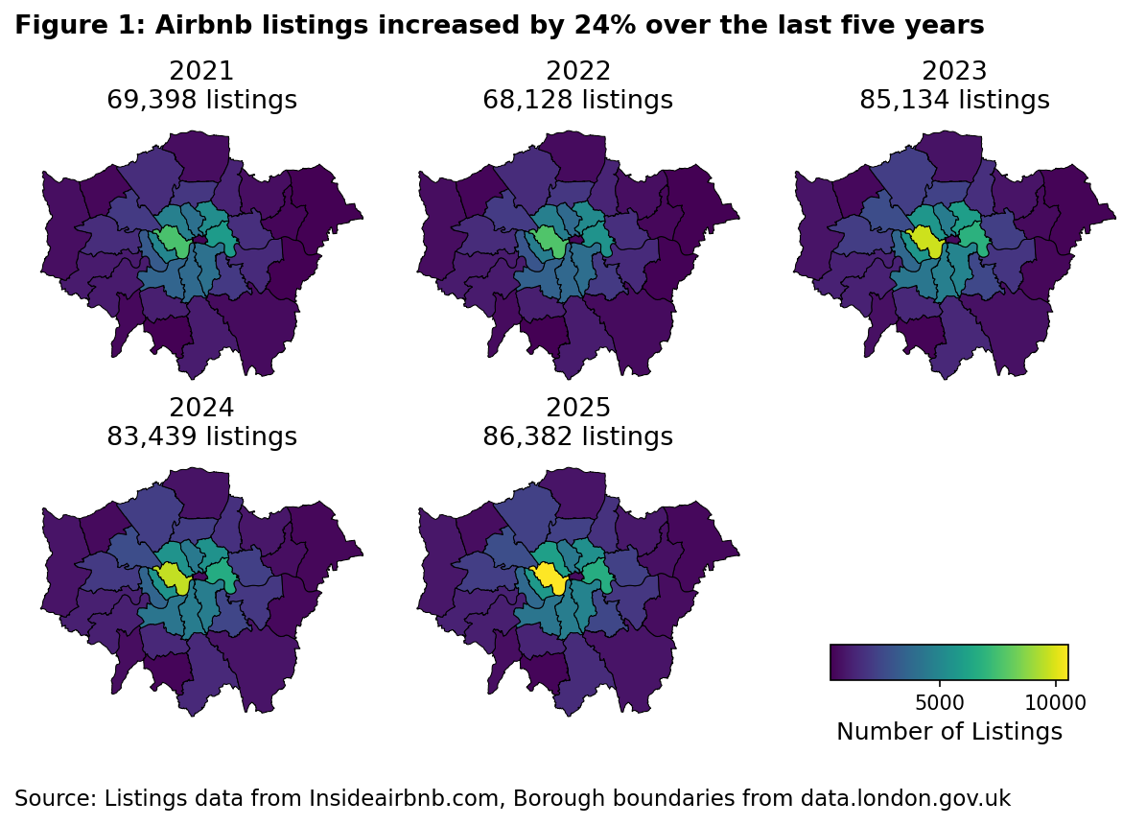
Most of the increase occurred between 2022 and 2023, with new listings concentrated in inner London boroughs:
- Westminster, Camden, Southwark, Lambeth, and Kensington and Chelsea saw the highest increases.
- Westminster alone added nearly **3,000** listings, constituting a **39% increase** in the borough.
By contrast, between 2020 and 2024 London’s housing stock grew from **3.68 million to 3.81 million properties: a relatively small **3.7% increase**. Kensington and Chelsea saw **5 times** more new Airbnb listings than new housing stock.
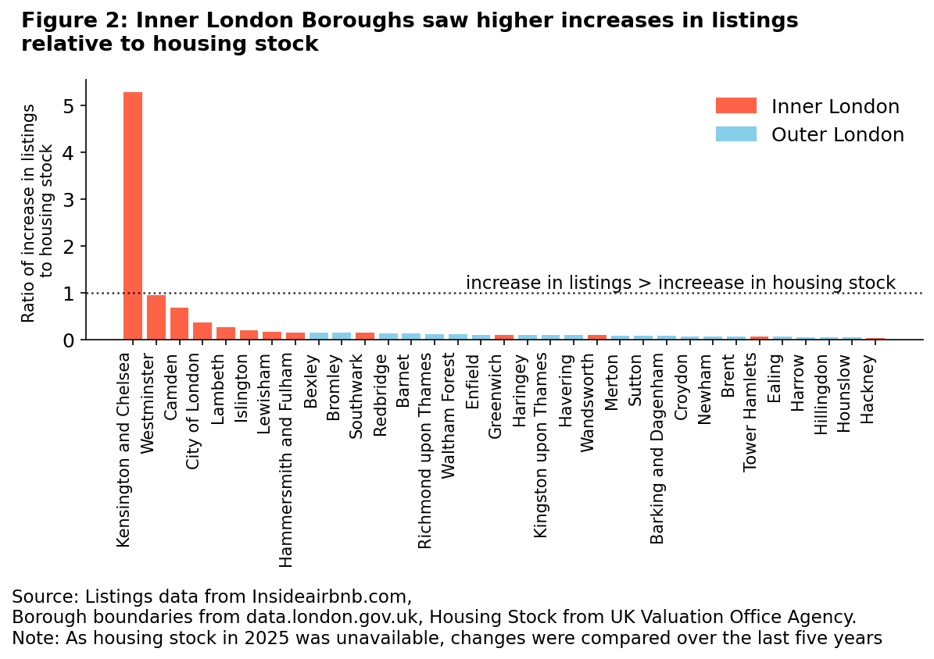
Across all London boroughs in 2025, the average amount of listings as a percentage of total housing stock was **1.86%**, though eleven boroughs exceed this average. These eleven are in inner London. Close to **6%** of the total housing stock in both Westminster and Kensington and Chelsea is listed as an Airbnb (Figure 1.2). At MSOA-level, up to 1 in 8 homes are listed on Airbnb in inner London (Figure 1.3).
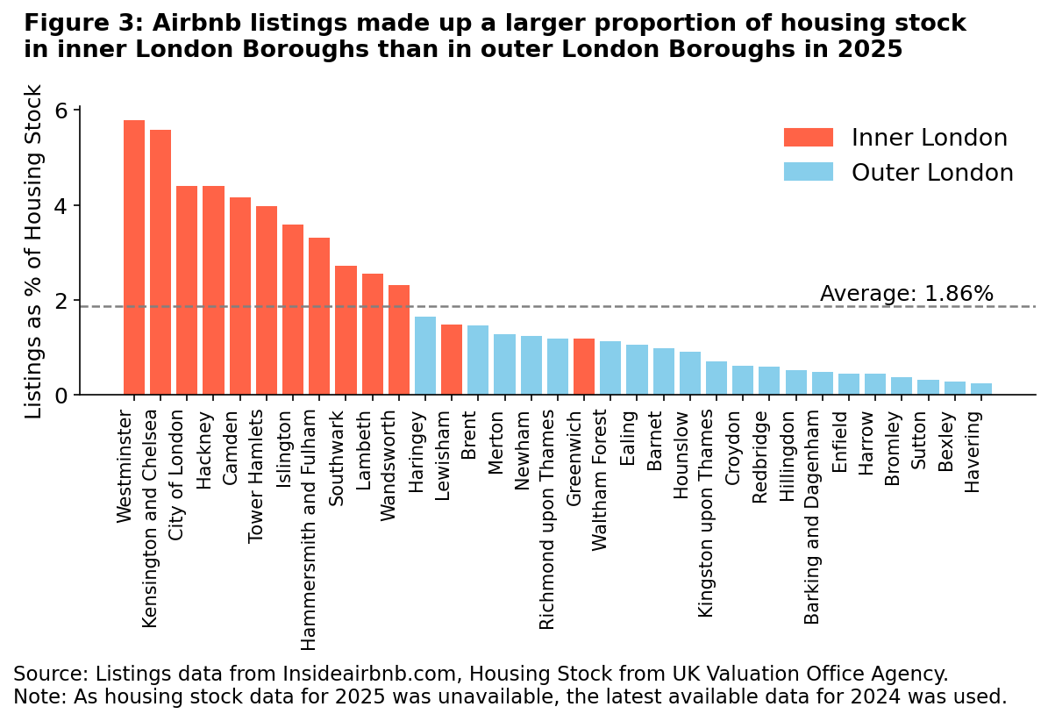
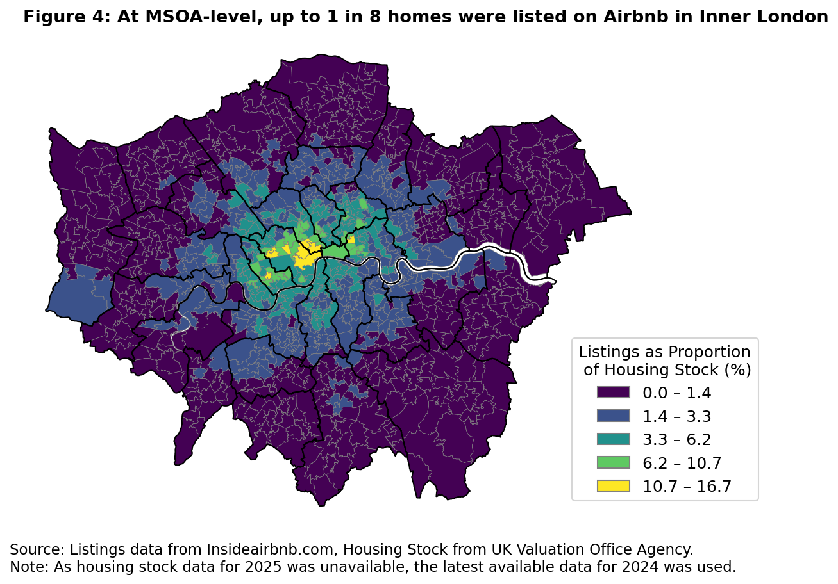
The growth of Airbnb properties therefore far outstrips the rate of growth of new housing available, particularly in inner London boroughs.
In such a tight housing market, this exacerbates pressure on housing prices and rents [link] (Todd, Musah & Cheshire (2022)), driving a perception that Airbnb is “out of control” in some parts of London.
Are hosts flouting the regulations?
Based on occupancy estimates [fn2], 12,081 entire homes / apartments (“entire homes”) were used for 90 or more nights per year ("frequent lets"). This represented more than 1 in 5 of all entire-homes listings, and 1 in 8 of all listings in London.
Again, inner London boroughs show the highest rates of intense use. Westminster, Camden and Islington had 27%, 25% and 23% of entire home listings as frequent lets, respectively.
Notwithstanding the sensitivity of assumptions, we expect this to be a conservative estimate, given the reported likelihood of multiple listings of the same property, which some owners have used to circumvent the 90-day rule [fn3, 4].
One action that could be taken in response to the opposition’s claims is to investigate how many of these listings are compliant with the planning permission requirement and take the appropriate enforcement action against hosts in breach. [This of course implies a commitment of finances and resource.]
- Taking back “control”?
The opposition proposes that “professional” landlords’ properties should be subject to registration and increased council tax. As above, the Mayor’s office has already proposed a registration system for landlords, and this should be made clear in any response to the opposition.
The opposition has not defined “professional” landlord or provided details of how such a system would be implemented. We therefore attempt to define and scope these points to aid a response.
What is a professional landlord?
Studies suggest that a company or individual that owns and operates 2 or more entire homes can be classed as a commercial or professional landlord. Such "multi-listing hosts" are significant drivers of increase in rent and of Airbnb's profit in London (Todd et al., Cox and Slee).
The data show that a small number of hosts are responsible for a disproportionately large number of listings in London (Figure 2.1):
- 27,108 (85%) hosts own only 1 entire property (“single-listing hosts”), and they are responsible for 47% of listings.
- 4,966 (15%) hosts own two or more entire properties (“multi-listing hosts”), and they disproportionately make up 53% of listings.
- 15 (0.05%) hosts own over 100 entire properties; between them, they own 5% of listings.
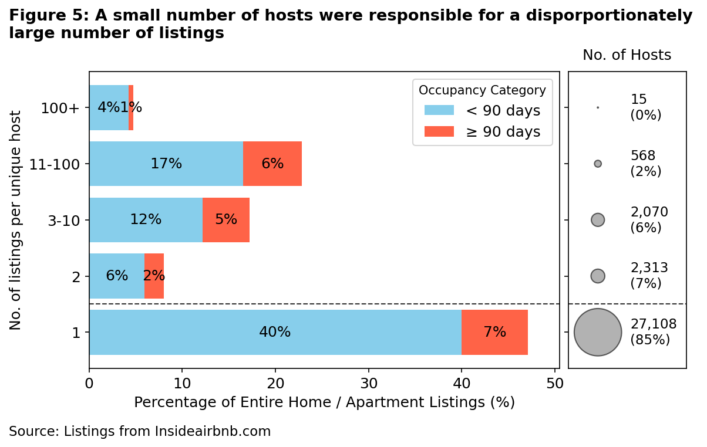
A larger proportion of properties belonging to multi-listings hosts were let out for 90 or more days (“frequent lets”) (14%), compared to properties belonging to single-listing hosts (7%).
Using the two-property threshold, therefore, 15% of Airbnb hosts currently letting entire homes in London would be treated as “professional” landlords.
We test the robustness of this analysis in a London context by:
- Establishing the income earned from renting out entire homes on Airbnb.
- Comparing this with the London median income, on the basis that a host earning this much could, in theory, treat this as their sole employment. The latest (2022-23) London Data Store figures give the median income for London as **£34,100**.
Based on estimated revenues:
- The median single-listing host renting out their home for “standard lets” earned £4,858 a year per property, while the median multi-listing host earned £5,600.
- The median single-listing “frequent lets” host earned £24,000 a year per property, while multi-listing “frequent lets” hosts earned £30,300.
- 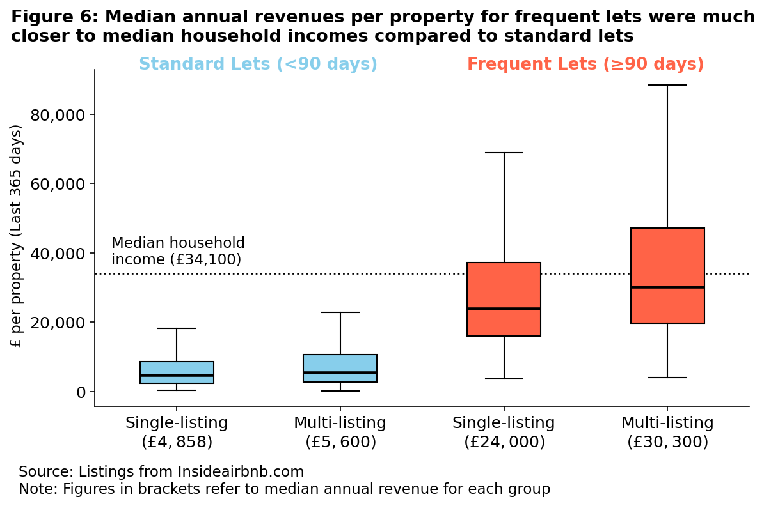
Using the more conservative income from single-listing hosts on standard lets (£4,858), owning seven properties becomes the threshold to make more than the London median income.
However, with frequent lets, owning two properties is sufficient to make close to double the median income of London when letting for at least 90 days a year. ,
Just 2 properties can generate nearly double the median income of London. Under this analysis:
- .
- Categorising any host owning 2 or more entire properties as a “professional” landlord is a defensible position.
- The aide at the centre of the current controversy would be classed as a professional landlord, which the Mayor should be mindful of when responding.
If the opposition’s proposal were implemented using this definition, **30,154** properties would be subject to increased council tax. This constitutes **53%** of all entire homes listings.
Who are London’s “professional” landlords?
Most ofboth single and multi-listing hosts are UK-based. However, at least one of the hosts that owns over 100 properties is a company based abroad (Dubai), and three others have names suggesting that they are companies.
[X% of] listings do not provide a host location; if all those hosts whose location is not listed are established to be based abroad; given previous cooperation on the part of Airbnb, it might be possible to find out more about these listings through them .
- Evaluating the opposition’s proposal
Is council tax an appropriate additional control?
The viability of the opposition’s proposal relies on generating a fiscally significant income stream to compensate for the perceived disbenefits of the high proportion of Airbnb properties in London. They suggest relying on the council tax system.
[Council tax applies to a property’s domestic classification, based on its 1991 valuation. All properties in the same band currently pay the same rate of council tax, unless an exemption applies. It is therefore not a mechanism designed to assess current commercial use or income, making it a blunt instrument for targeted market intervention.
The opposition do not explain how the council tax system might be adjusted, but we note that the recent 2025 Budget will modify the council tax system from 2028 to apply a surcharge on very expensive properties, using 2026 valuations. Therefore, there is potentially more flexibility in the system than has historically been the case, and a system “piggybacking” on these changes could be explored.
To illustrate potential revenues from council tax adjustments, we calculated the estimated revenue based on a 2-15% premium applied to the current council tax Band D rate for all properties operated by professional landlords.
This intervention targets a high-value segment, yielding between £1 and £7 million . Inner London boroughs, which are the focus of much of the housing debate, account for £0.7-5.6 million of this total.
This spatial concentration of potential revenue allows the Mayor to justify the policy as one specifically taxing the central areas, where commercial exploitation of housing stock is most acute, rather than a blanket tax rise across London.
However, the logistics of how this change would be implemented remain to be determined:
- A targeted surcharge affecting “professional” Airbnb hosts (in the manner of the Budget’s “Mansion Tax” surcharge) is likely to see far less pushback than a general increase in council tax for all properties.
- Determining which bands should be affected is not straightforward, as properties of all types and values are available for short-term let on Airbnb and other platforms.
Premium Rate | Revenue (London Wide) | Revenue (Inner London Only)
2% | £1,007,289.0 | £749,877.3
5% | £2,518,222.5 | £1,874,693.3
10% | £5,036,445.0 | £3,749,386.6
15% | £7,554,667.5 | £5,624,079.9

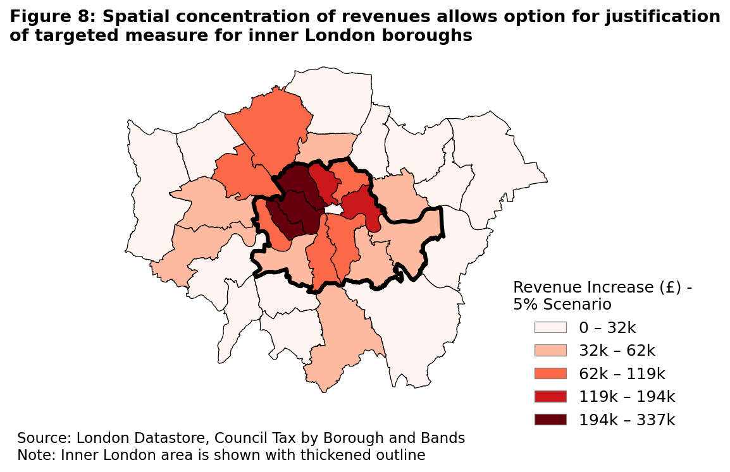

Can we do better?
[Given that some existing Airbnb hosts are companies, and that a great deal more would be required to register as “professional” landlords if some form of the Mayor’s (and opposition’s) proposals were carried out, an alternative that relies on an existing regulatory infrastructure might be business rates.]
Business rates are triggered when a property is used for commercial purposes and are designed to identify true commercial exploitation that should be liable to taxation. [That this is a framework of which Airbnb hosts should be aware already is clear from, for example this Airbnb article]
The business rates requirement for short-term lets is that they must be registered once the threshold of, typically, 140 days of availability per year is reached.
There is, therefore, a mismatch between the planning permission requirement and the business rates requirement in terms of when registration is required, which would have to be addressed if this avenue were explored.
Another option is to introduce a form of “tourist tax”, a common approach in other countries. The Hackney Citizen estimates that such a measure could raise £240 million a year and, if implemented with care, would not necessarily reduce visitor numbers. This could be a more targeted and easily administered approach, without relying on property valuations or on enforcement against reluctant or elusive landlords.
- Weighing up the way ahead: pros, cons and social mobility
While the opposition now agrees with the Mayor’s intent to curb the negative impacts of short-term lets in London, their proposal is blunt and scant on detail. It risks undermining London’s thriving tourism industry, which contributes at least £10 billion a year to London’s economy and supports around 7% of London’s jobs, while failing to distinguish between a small number of problematic commercial operators and the many residents who host legitimately. Moreover, the London short letting market is already more tightly regulated than its European equivalents.
For ordinary Londoners, hosting often provides a modest but meaningful supplement to household income, helping them manage rising living costs and maintain financial stability. . Research from 2022 also highlights that older women living alone and women with disabilities increasingly rely on hosting as a flexible lifeline. For many just renting out a room, earnings are generally modest: the median annual revenue for a private room let under 90 days is below £2,000, rising to around £10,000 for frequent lets. From the perspective of promoting social mobility, introducing additional complexity and costs through untargeted council tax increases would be a backward step. While better-off “professional” hosts would be able to absorb these additional burdens and would not necessarily release their properties onto the housing market, individual hosts may see the benefit of letting their property diminished to the point of exiting the market, to the detriment of their finances and security.
Given that subletting council accommodation is illegal, the aide's circumstance will inspire inevitable backlash and embarrassment. In the interest of public trust, a full investigation should take place to uphold transparency in the Mayor's Office. With this, it is possible that the aide received legitimate permissions to sublet and list the council housing. In which case, previous data suggests that many hosts would require up to seven listed properties to make more than the London Average, something the aide cannot claim. This context could display the opposition as politically rancorous and against the more egalitarian and modest hosts described above.
Our analysis has shown that the key problems are concentrated among a subset of professional operators in specific boroughs. A blanket approach such as raising council tax for all would therefore penalise responsible hosts while doing little to address true sources of pressure. A targeted strategy, which could combine a tourist tax with a focus on ensuring that relevant professional landlords are registered for and paying business rates would be more proportionate, more effective, and better aligned with the Mayor’s aim of reducing harm without compromising London’s vibrancy or the livelihoods of ordinary residents.

Bosco: [Notes on limitations of the data sets]
Inside Airbnb dataset
Apart from the limitations of the occupancy estimates previously mentioned, it is possible that listing numbers are underestimated in the cleaning process in response to inaccuracies in scraping. Moreover, the dataset is only a snapshot in time. Since listings can be added or deleted, seasonal/temporary listings might be over/under- represented.
Our methodology also does not tell how many frequently let properties have legitimate planning permissions. If we have more time, we can connect to the Planning London Datahub’s public API and extract the number of short-term let permissions to provide an estimate. As short-term let falls into “sui generis” rather than an independent use class, the only way to filter them out is by building text regex pattern to search for them from the planning permission descriptions, which is time intensive.
Housing stock dataset
Using a raw stock of properties dataset to normalise Airbnb listings can overlook variations in housing stock. Some areas can have less Airbnb-eligible dwellings (eg. care homes), and some areas can have higher vacancy rates than others.

